Climate change and livestock in the Murray Basin NRM Cluster region
The Murray Basin NRM Cluster makes a significant contribution to Australia's economic growth and food security. It covers parts of New South Wales, Victoria and South Australia, ranging from coastal to inland regions. This information is part of a series of factsheets highlighting changes and options for the region associated with climate change.

Agriculture in the Murray Basin NRM Cluster region
Agricultural activities within the Murray Basin NRM region are diverse, ranging from intensive horticulture to grazing. Some important climate predictions* for the near future (by 2030) are
- higher temperatures
- hotter and more frequent hot days and fewer frosts
- less rainfall in the cool season but no changes for the warm season
- an increase in heavy rainfall events and more time in drought
- a decrease in humidity over winter and spring
- increases in evaporation rates and reduced soil moisture
- sea levels will rise and more frequent sea level extremes will occur.
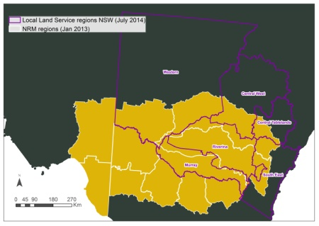
The Murray Basin NRM Cluster Region covers some 500,000 km². It is extremely diverse and includes flat plains to high mountains, above- and below-ground water resources and a broad range of biodiversity. Many different types of agriculture also occur in this region.

These changes present both challenges and opportunities for agriculture across the region. By broadly identifying the changes that

agriculture will face across the Murray Basin NRM region we can prepare for future challenges and watch for new opportunities as they arise.

Insert NRM name here
Each NRM can customise factsheet here to provide a brief description of their region and key agricultural industries associated with this factsheet in this area.
X
X

Potential impacts
Climate change is likely influence livestock in several ways:

Pasture productivity
Changes to the amount and timing of rainfall may reduce pasture production in some regions, especially along the eastern and drier western margins of the Murray Darling Basin. Higher temperatures may increase pasture growth in cooler months but shorter growing times may limit production. Changes to pasture productivity will alter the carrying capacity of many farms.

Forage quality
Forage quality is based on the balance of carbohydrates, proteins and digestibility. Rising CO₂ may increase plant biomass but may also decrease protein content and digestibility, thereby reducing forage quality. Warmer conditions can also reduce digestibility.

Animal husbandry and health
An increase in the number of heat stress days is predicted to reduce productivity and reproduction and impact on the welfare of animals in intensively managed enterprises such as piggeries and feedlots.

Pests, diseases, feral animals and weeds
Shorter winters and longer dry summers reduce breeding windows for rabbits and feral pigs. But feed and water shortages in drier times may increase competition between kangaroos and livestock. Warmer temperatures are likely to increase growth rates in weeds. Changes to insect breeding cycles may require adjustments to the timing of control measures while shifts in the current range of many pests, feral animals, diseases and weeds may create new threats.

Native Pastures
Rainfall variation is likely to change the composition of native pastures, including a shift towards less desirable species and weeds. Regions that become hotter and drier may see an increase in plants that are more able to cope with these new conditions but these may be less palatable and digestible. Deep-rooted perennials and legumes may also increase as these are more able to tap into deeper water sources.

Other impacts
Factors such live weight, wool growth, reproduction and milk production are strongly related to the availability of young, digestible plant material. Other impacts may come through changes in cropping systems that may impact on the grain feed and fodder crops while limited water availability will impact on fodder supplies and stock water.
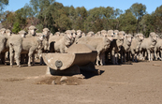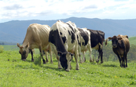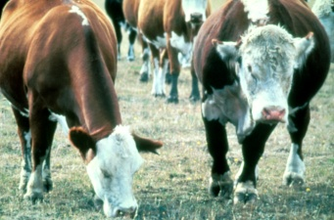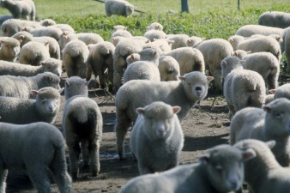
Some important livestock in our region that might be affected by climate change. NRMs to add/modify photos as required
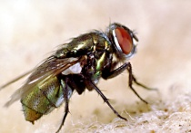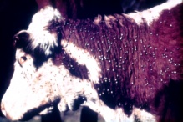
Pests, diseases and weeds may move to new areas.

Adaptation options
Some suggestions for managing livestock under changing climates include:
- Closely monitor stocking rates, and consider more strategic spelling, rotation and grazing of paddocks
- Changing the mix of annuals and perennials in pastures to match nutritional demand and climatic conditions
- Consider increasing the use of native grasses and palatable species
- Where possible, increase forage cropping during winter and change the timing of cutting silage and hay to better match the changing pasture curve
- Modify the timing of mating based on seasonal conditions and fodder availability
- Other possible changes include providing livestock with improved cooling and shade to help counteract heat stress.

Further Information
If you would like to know more please contact your local office:
:
:
:
:
[Prepared by Dr Linda Broadhurst CSIRO; Telephone: 02 6246 4988; Email: Linda.Broadhurst@csiro.au]

Information sources and additional reading
- P. Deuter (2008) Defining the impacts of climate change on horticulture in Australia. (http://www.garnautreview.org.au/CA25734E0016A131/WebObj/01-GHorticulture/$File/01-G%20Horticulture.pdf)
- P. Deuter (2009) Australian horticulture's response to climate change and climate variability. (http://www.horticulture.com.au/librarymanager/libs/162/AH06019%20Project%20Final%20Report.PDF)
- M. Howden et al (2008) An overview of the adaptive capacity of the Australian agricultural sector to climate change - options, costs and benefits. (http://www.cse.csiro.au/publications/2003/AGOAgClimateAdaptationReport.pdf )
- NACCAP Communicating Climate Change (2008) (http://www.mla.com.au/files/56187cfb-ba03-4bec-883b-9d66008a8f15/Climate-change-weeds-and-pests.pdf)

