Climate change and horticulture/viticulture in the Murray Basin NRM Cluster region
The Murray Basin NRM Cluster makes a significant contribution to Australia's economic growth and food security. It covers parts of New South Wales, Victoria and South Australia, ranging from coastal to inland regions. This information is part of a series of factsheets highlighting changes and options for the region associated with climate change.

Agriculture in the Murray Basin NRM Cluster region
Agricultural activities within the Murray Basin NRM region are diverse, ranging from intensive horticulture to grazing. Some important climate predictions* for the near future (by 2030) are
- higher temperatures
- hotter and more frequent hot days and fewer frosts
- less rainfall in the cool season but no changes for the warm season
- an increase in heavy rainfall events and more time in drought
- a decrease in humidity over winter and spring
- increases in evaporation rates and reduced soil moisture
- sea levels will rise and more frequent sea level extremes will occur.
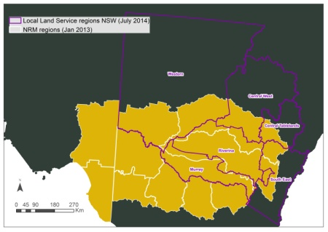
The Murray Basin NRM Cluster Region covers some 500,000 km². It is extremely diverse and includes flat plains to high mountains, above- and below-ground water resources and a broad range of biodiversity. Many different types of agriculture also occur in this region.

These changes present both challenges and opportunities for agriculture across the region. By broadly identifying the changes that

agriculture will face across the Murray Basin NRM region we can prepare for future challenges and watch for opportunities as they arise.

Insert NRM name here
Each NRM can customise factsheet here to provide a brief description of their region and key agricultural industries associated with this factsheet in this area.
X
X

Potential impacts
Changes to temperature and water availability are likely to affect horticulture and viticulture well as some day to day farming practices. Some of these changes are outlined below.

The timing of production
Many horticultural crops are sensitive to water availability, temperature and extreme weather events. Consequently, planting and harvesting windows for some crops are likely to change. Harvesting of crops such as grapes and citrus in the Riverina may occur up to 10-14 days earlier while increased soil temperatures in spring will allow some crops to be planted earlier. While these may not seem like a big changes, they are likely to have flow on effects for farm activities such as workforce planning, fertilizer purchase and transport to market.

Crop yield and quality
Increased heat stress will affect the quantity and quality of many crops, especially for cultivars that are not adapted to higher or more variable temperatures. Out-of-season high temperatures induces bolting in crops such as lettuce and spinach while capsicum flowers abort when temperatures go above 30C. Crops that require chilling for bud development or crop set may be affected by changes to the timing and frequency of frosts. Declines in crop pollinators or mismatches between crop flowering and pollinators being available may also occur. Reduced water availability and increased salinity will also influence crop quality and yields.

Horticultural inputs
More irrigation water will be required to meet increased evaporation rates and faster plant growth in some crops. For example, more water will be required to prevent tipburn in lettuce and blossom-end rot in tomatoes while additional overhead irrigation may be needed to cool lettuce and other leafy vegetables. Increased competition for water resources is also likely. Other changes include pumps running under hotter temperatures being less efficient and more prone to breakdown, and, additional summer cooling being required for greenhouses (although these will require less heating over winter). Farm-related costs such as freight, packaging, pesticides & fertiliser, fossil fuels and labour are likely to increase.

Pests and diseases
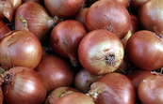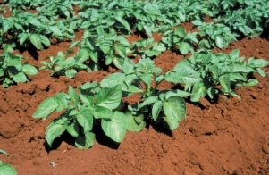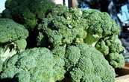
Some important crops in our region that might be affected by climate change. NRMs to add/modify as required
Higher temperatures are likely to increase pest and disease activity, alter the rate at which these grow and develop, and increase their chances of survival. Some pests and diseases will also colonise new areas. Beneficial insects that keep some of these pests in check may also be affected.
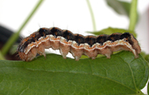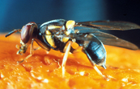
Pests and diseases may move to new areas.

Post harvest changes
Increased temperatures may change the look (and possibly taste) of some crops. Poor citrus rind colour associated with higher night temperatures may occur in the Riverina. Re-greening of Valencia’s during summer will take longer while degreening may be required for navel oranges in southern regions. There may also be new costs associated with grading and marketing of susceptible fruit and vegetables to remove blemished products. Post harvest cooling costs for many crops will increase as additional field heat will need to be removed prior to transport.

Adaptation options
Some suggestions for managing crops under changing climates include:
1. Changing to new crop varieties where possible
2. Monitoring and adjusting planting and harvesting times
3. Looking for new and innovative ways to use water
4. Monitoring potential pests and diseases to take action early

Further Information
If you would like to know more please contact your local office:
:
:
:
:
[Prepared by Dr Linda Broadhurst CSIRO; Telephone: 02 6246 4988; Email: Linda.Broadhurst@csiro.au]

Information sources and additional reading
- P. Deuter (2008) Defining the impacts of climate change on horticulture in Australia. (http://www.garnautreview.org.au/CA25734E0016A131/WebObj/01-GHorticulture/$File/01-G%20Horticulture.pdf)
- P. Deuter (2009) Australian horticulture's response to climate change and climate variability. (http://www.horticulture.com.au/librarymanager/libs/162/AH06019%20Project%20Final%20Report.PDF)
- M. Howden et al (2008) An overview of the adaptive capacity of the Australian agricultural sector to climate change - options, costs and benefits. (http://www.cse.csiro.au/publications/2003/AGOAgClimateAdaptationReport.pdf )

