Climate change and biodiversity in the Murray Basin NRM Cluster region – how will it affect your region?
As well as being a region of high natural value and environmental importance, the Murray Basin Natural Resource Management (NRM) Cluster makes a significant contribution to Australia's economic growth and food security. It covers parts of New South Wales, Victoria, South Australia and the ACT, ranging from coastal to inland regions. This information is part of a series of factsheets highlighting changes and options for the region associated with climate change.

Biodiversity in the Murray Basin NRM Cluster region
Biodiversity in the Murray Basin NRM Cluster region is supported in many different terrestrial and aquatic environments including forests, woodlands, shrublands and grasslands as well as in river and wetland systems. Predicting how our populations, species and communities will respond to climate change is challenging as each of these systems is likely to react differently. We all want to keep our biodiversity healthy so that our children and grandchildren can enjoy it just as we have. This means that it’s important to know what changes to biodiversity might look like and how we can help. Looking ahead and managing change helps us to decide how much change we want occur naturally and when we feel we should step in to help species.
Some of the climate predictions* for the near future (i.e. by 2030) that are likely to affect on biodiversity include:
- higher temperatures

- hotter and more frequent hot days and fewer frosts
- less rainfall in the cool season but no changes for the warm season
- an increase in heavy rainfall events and more time in drought
- a decrease in humidity over winter and spring
- increased evaporation rates and reduced soil moisture
- sea levels will rise and more frequent sea level extremes will occur.
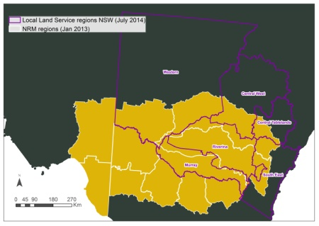
The Murray Basin NRM Cluster Region covers some 500,000 km². It is extremely diverse and includes flat plains to high mountains, above- and below-ground water resources and a broad range of biodiversity. Many different types of agriculture also occur in this region.

Insert NRM name here
Each NRM can customise factsheet here to provide a brief description of their region and key agricultural industries associated with this factsheet in this area.
X

X

Biodiversity and change
Biodiversity in the Murray Basin NRM Cluster region has already faced change. Factors such as invasive pests and diseases, vegetation degradation and a loss of connectivity have changed how much biodiversity remains in the Murray Basin NRM region, how healthy it is, and how likely it is to remain in the future. Climate change adds a new dimension to what is already happening by directly affecting our native species and by changing the ways other threats interact with them.
Almost all biodiversity will be affected by climate change but some areas in the Murray Basin NRM region will be more affected than others. Alpine areas, coastal fringing habitats including wetlands, and freshwater systems are probably the most vulnerable [1]. This is not to say that other areas are not important, just that these regions may be the first areas to show signs of change. Plants and animals on coastal shores may be affected by rises in sea level, extreme weather events and changes to food sources [2].

Potential impacts
Reduced water availability and increased temperatures will drive how our biodiversity responds to climate change. Here we outline some of the changes to biodiversity that are currently taking place or may take place in the future.

Terrestrial plants and animals
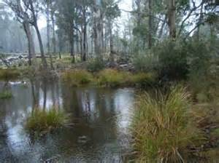
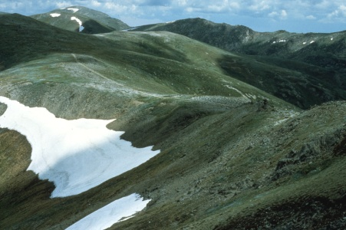
Many Australian plants respond to environmental cues, such as rainfall, to begin flowering. Any changes to the timing and amount of rainfall will influence when and the amount of flowering that will occur. These changes can have flow-on effects on the types and numbers of pollinators, which can ultimately influence how much seed plants produce. Seed is an important part of the diet of many animals and can be required by some animals to complete their lifecycle (e.g. insect larvae). More specific predictions about how particular species or groups will respond to climate change are hard to make but some information is beginning to emerge. For example, many eucalypts occur in relatively small areas that are closely tied to soil and drainage; these small areas can also coincide with narrow climatic ranges [3]. While it is not clear how much change eucalypts can tolerate, it is likely that some of them will need to move into new areas to survive [3]. On the other hand, acacias may be more robust to modest warming and the ranges of these species may contract rather than them colonising new areas [4]. Some plants may also be more susceptible to insect attack but early information suggests that this may not be a major issue with each species responding differently [5,6].
Changes to vegetation can also influence how animals will respond. For example, changing vegetation condition along riverbanks can influence bird richness and abundance [7] while riparian tree cover can help larger invertebrates (‘macro-invertebrates’) cope better during drought [8]. Heat stress can also have a major impact on the health and survival of animals. For example, in 2002, heat stressed killed ~3,500 flying foxes, including the Nationally Vulnerable Grey-headed Flying-fox, on a single day across parts of southeastern Australia [9]. In 2010, ~200 Carnaby’s Black cockatoos, which are Nationally Endangered, probably died from heat stress in Western Australia [10]. Migratory birds are also changing their behaviour with some becoming year-round residents, increasing competition with local species for food and other resources [2]. Feed and water shortages in drier times may increase competition between kangaroos and livestock. Some animals that have already been identified to be at risk from climate change include the Mountain Pygmy-possum (listed Nationally as Endangered) and birds confined to southern South Australia [11].

Aquatic plants and animals
As with terrestrial plants and animals, temperature and water availability will affect freshwater and riverine species. Drought can substantially influence plant and animal diversity with recent studies showing that aquatic insect communities were colonised by species better able to tolerate low water flows and poor water quality during the Millennium drought [8]. These changes can affect fish and birds that rely on these species for food. Increased temperatures may also affect the survival and breeding of native fish since these species can have very specific temperature requirements [2]. Amphibians are also highly vulnerable to climate change [12] with the Nationally Critically Endangered Northern Corroboree frog already identified as a species at risk [11]. Changes to water flows and availability that result in increased salinity or black water and low oxygen events can rapidly change fish diversity and survival [13,14]. Fish that may be most at risk from climate change and drought include those that live in specialised habitats, mostly eat invertebrates, are small and do not produce many young [13,15].
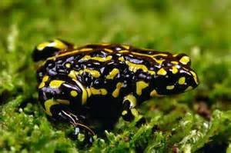

Soil communities
Very little is known about how soil microbes and insects will respond to climate change. However, these communities are important for many processes such as carbon and nutrient cycling. Soil communities are known to respond to changes in moisture and temperature [2] so it is likely that the processes they are responsible for will also change.

Pests and diseases
Climate change is also expected to influence pests and diseases. For example, invasive fish are already expanding their ranges while Lippia, an important plant invader of aquatic systems, may also expand into new areas [2]. Some native species may also become invasive in the future as they move to new regions [2].

Species movement
Plants and animals have three main options to cope with change:
- To stay put, but eventually they may be unable to cope and will die out (extinction)
- To stay put and learn to cope (adaptation)
- To move to more suitable places (migration).

Extinction
Plants and animals that cannot adapt or migrate are at greatest risk of dying out. Species with restricted distributions, small populations, long reproductive cycles and are highly specialised will be the most vulnerable to climate change [2]. Species with a poor ability to move or colonise new areas are also at risk of extinction. Some of the most vulnerable species for the Murray Basin NRM region are likely to occur in the alpine zone, semi-arid rangelands, coastal fringing habitats including wetlands, and freshwater systems [1,3]. It can be hard to see extinction coming as species often enter a slow decline and then die off quite suddenly [2].

Adaptation
Plants and animals can adapt to change in two ways:
- Phenotypic plasticity is when changes occur within an organism’s lifetime but is not associated with a genetic change, (e.g. plants may not grow as tall and may produce fewer leaves when water stressed), and,
- Evolution is when a genetic change occurs that helps the organism cope with the new environment (this happens over very long periods of time).
Many species already have some level of plasticity that helps them cope with change. For example, some plants can withstand wet and dry years by adjusting their water and nutrient requirements while animals will rest during the hottest part of the day. However, it is unclear how many species will be able to cope with the predicted change. Species most likely to be affected are those with restricted distributions, small populations and long reproduction cycles [2]. While plants and animals may be able to adapt their behaviour or biological processes up to a point, some change may be so great that they will have to move.

Migration
Species movement in the Murray Basin NRM Cluster is predicted to be complex. Some species will probably broaden their range while others will contract. Species with very specific living requirements may have to live in small pockets of suitable habitat called refugia. This makes them vulnerable to extinction from many factors including fires and storms. Many alpine species are expected to move to higher altitudes where possible. Across Australia some species have already started to migrate (e.g. the northern limit of the Grey-headed Flying-fox is now 750km further south than it was in the 1930s [2]). Theoretically plants and animals are capable of moving to new places, but in reality it can be very difficult for them to move. For birds, animals and insects to successfully relocate they require:
- A safe pathway (i.e. native vegetation through which they can safely travel that has sufficient food and habitat and is predator-free)
- A suitable new home (i.e. the same requirements as a safe pathway but there needs to be sufficient resources to support these birds, animals and insects in the long term).
For some species these pathways and new safe havens do not currently exist and will need to be provided through restoration. Migration may also put additional pressure on species already living in these areas. Plants that rely on animals to move their seed may find it especially difficult to colonise new areas.

What can I do?
There are many things we can all do to help biodiversity adapt to climate change including:
- Engage with your local NRM, council and landcare group to stay informed of what changes are occurring in your region and how you can help.
- Increasing the size of populations, reconnecting them and improving their health is important. This will ensure that organisms have the best possible chance of adapting to change.
- Change is inevitable and local species you know and love may need to move to new areas to survive. The good news is that new species will replace them, although it this may take some time.
- Keep watch for new threats such as pests and diseases not previously seen in your area. Stay in touch with your local NRM, council and landcare group and let them know when you see something unusual.

Information and further reading

1. Hughes L (2011) Climate change and Australia: key vulnerable regions. Regional Environmental Change 11: S189-S195.

2. Commonweath of Australia (2011) The Garnaut Review 2011: Australia in Response to Climate Change. Melbourne: Cambridge University Press.

3. Hughes L (2003) Climate change and Australia: Trends, projections and impacts. Austral Ecology 28: 423-443.

4. Pouliquen-Young O, Newman P (2000) The implciations of climate chnage for land-based nature conservation strategies. Final report 96/1306. Australian Greenhouse Office, Environment Australia, Canberra and Insitute for Sustainability and Technology Policy, Murdoch University, Perth, Australia.

5. Moir ML, Vesk PA, Brennan KEC, Hughes L, Keith DA, et al. (2012) A preliminary assessment of changes in plant-dwelling insects when threatened plants are translocated. Journal of Insect Conservation 16: 367-377.

6. Nooten S, Hughes L (2014) Potential imapcts of climate chnage on patterns of insect herbivory on understorey plant species: a transplant experiment. Austral Ecology 39: 668-676.

7. Mac Nally R, Lada H, Cunningham S (2014) Climate-change-driven deterioration of the condition of floodplain forest and the future for the avifauna. Global Ecology and Biogeography 23: 191-202.

8. Thomson JR, Bond NR, Cunningham S, Metzeling L, Reich P, et al. (2012) The influences of climatic variation and vegetation on stream biota: lessons from the Big Dry in southeastern Australia. Global Change Biology 18: 1582-1596.

9. Welbergen J, Klose S, Markus N, Eby P (2008) Climate change and the effect of temperature on Australian flying-foxes. Proceedings of the Royal Society B-Biological Sciences 275: 419-425.

10. Saunders DA, Mawson P, Dawson R (2011) The imapct of two extreme weather events and otehr cases of death on Carnaby's Black Cockatoo: a promise of things to come for a threatened species? Pacific Conservation Biology 17: 141-148.

11. Steffan W, Hughes L (2013) The Critical Decade 2013: Climate chnage science, risks and responses. Canberra: Climate Commission Secretariat.

12. Mac Nally R, Nerenberg S, Thomson JR, Lada H, Clarke R (2014) Do frogs bounce, and if so, by how much? Responses to the 'Big Wet' following the 'Big Dry' in south-eastern Australia. Global Ecology and Biogeography 23: 223-234.

13. Wedderburn S, Barnes T, Hillyard KA (2014) Shifts is fish asemblages indicate failed recovery of threatened species following prolonged drought in terminating lakes of the Murray Basin, Australia. Hydrobiologia 370: 179-190.

14. Small K, Kopf R, Watts R, Howitt J (2014) Hypoxia, blackwater and fish kills: experimental lethal oxygen levels in juvenile predatory lowland river fishes. PLoS ONE 9: e94524.

15. Chessman BC (2013) Identifying species at risk from climate change: traits predict the drought vulverability of freshwater fishes. Biological Conservation 160: 40-49.

Further Information
If you would like to know more please contact your local office:
:
:
:
:
[Prepared by Dr Linda Broadhurst CSIRO; Telephone: 02 6246 4988; Email: Linda.Broadhurst@csiro.au]

